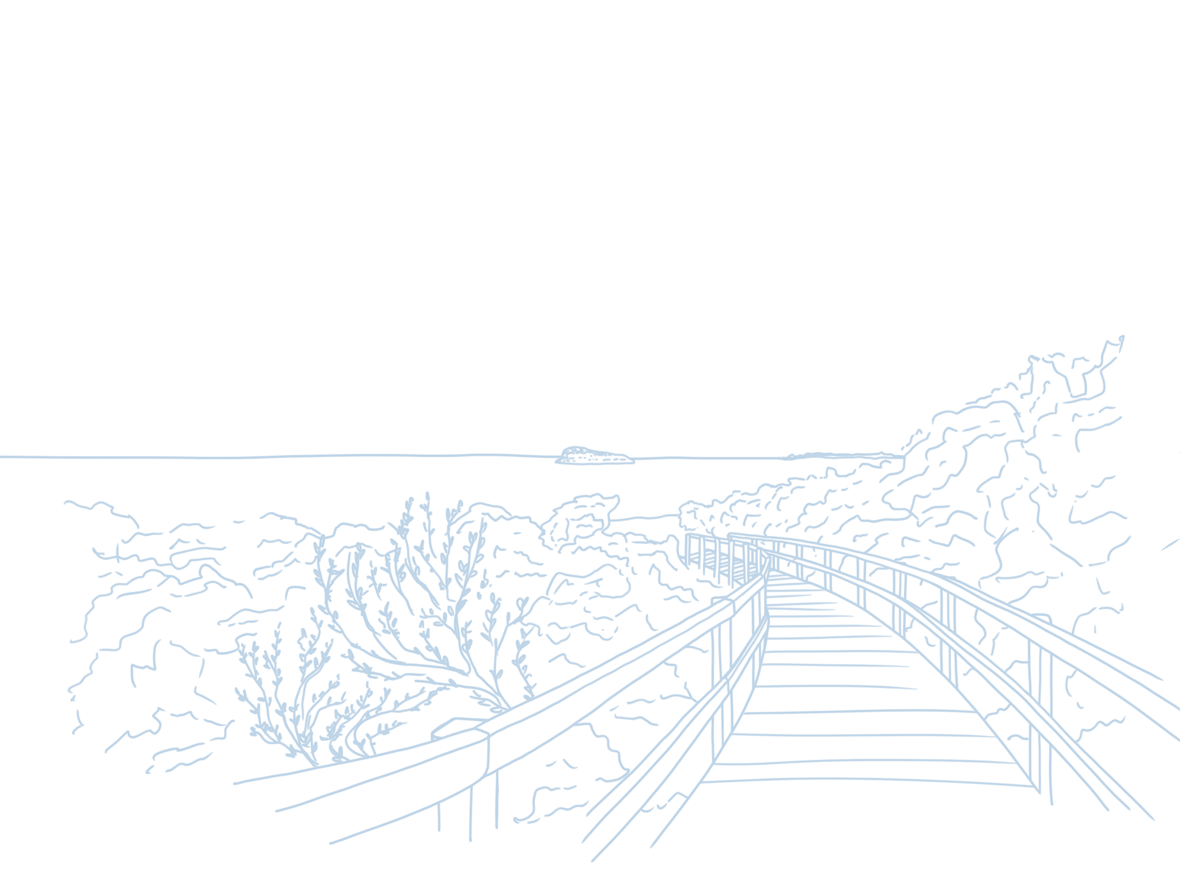
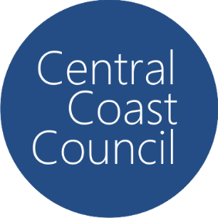
Central Coast Council

Central Coast Section 7.12
Local Infrastructure Contribution Plan 2023

Date Adopted: 28 November 2023
Revision: 1

Table of Contents

Part A – Summary Schedules 1

Part B – Administration and Operation of the Plan 2

1.1 Name of the Plan 2
1.2 Where does this plan apply? 2
1.3 When does this development contributions plan commence? 2
1.4 What is the purpose of this contributions plan? 2
1.5 Are there any exemptions to the levy? 2
1.6 Relationship to other contributions plans 3
1.7 Pooling of levies 4
1.8 Construction certificates and the obligation of accredited certifiers 4
1.9 How will the levy be calculated? 4
1.10 When is the levy payable? 5
1.11 How will the levy be adjusted? 5
1.12 Can deferred or periodic payments be made? 6

Part C – Expected development and demand for public facilities 8

Part D - References 8

Schedule 1 - Works Schedule 10

Schedule 2 - Maps 12

Schedule 3 – Cost Summary Reports 15

Plan History
Revision | Date Approved by Council | Operational From | Description Of Changes
1 | 28/11/23 | 29/1/24 | Original Draft – reported to Council on 28 November 2023 for Adoption.
2

Part A – Summary Schedules

In accordance with clause 209(2) of the Environmental Planning and Assessment Regulation 2021 (EP&A Regulation), the rate of the levy for development carried out on land to which this Plan applies is calculated as follows:

Proposed Cost of Development | Levy Rate
Up to and including $100,000 | NIL
More than $100,000 and up to and including $200,000 | 0.5% of the cost of development
More than $200,000 | 1% of the cost of development

Summary of project cost

Category | Estimated Cost
Open Space and Recreation | $4,050,000
Flooding and Drainage | $500,000
Cycleways | $42,465,207
Community Facilities | $3,000,000
Local Centre Upgrades | $1,000,000
Gosford City Centre Projects | $41,500,000
Total | $92,515,207

Part B – Administration and Operation of the Plan

1.1 Name of the Plan

Central Coast Section 7.12 Local Infrastructure Contributions Plan 2023.

1.2 Where does this plan apply?

The Plan applies to all land within the Central Coast Local Government Area

1.3 When does this development contributions plan commence?

This contributions plan commences on 29 January 2024.

1.4 What is the purpose of this contributions plan?

The primary purposes of this contributions plan are:

- To authorise the imposition of a condition on certain development consents and complying development certificates requiring the payment of a contribution pursuant to Section 7.12 of the Environmental Planning and Assessment Act 1979

- To assist the council to provide the appropriate public facilities which are required to maintain and enhance amenity and service delivery within the area

- To publicly identify the purposes for which the levies are required.

- To provide a comprehensive framework for the assessment, collection and expenditure of local infrastructure contributions; and

- To enable Council to be both publicly and financially accountable in its assessment and administration of the Plan.

1.5 Are there any exemptions to the levy?

The following development is excluded from the need to pay a development contribution under this Plan:

- Development with a development cost of less than $100,000;

- A dwelling house or alterations and additions to a dwelling house or any development ordinarily incidental or ancillary to the use of the dwelling house such as swimming pools, garages, sheds and the like;

- Development carried out on land that has been subject to a contribution paid under the Somersby Industrial Estate Service Agreement;

- Development undertaken by or on behalf of Council, including (but not limited to) works listed in the works schedule in Schedule 1 of this plan

- Alterations or refurbishment of an existing development, where there is no enlargement, expansion, increase in gross floor area or intensification of the current land use;

- An application for emergency services facility

- An application for educational establishments

- An application for demolition (where there is not a replacement building or development).

- Development excluded from Section 7.12 contributions by a Ministerial Direction under Section 7.17 of the Environmental Planning and Assessment Act 1979

Note: Where a development contribution under Section 7.11 of the Environmental Planning and Assessment Act 1979 has been required in respect of the subdivision of land, a levy under Section 7.12 of that Act may not be required in respect of any other development on the land, unless that other development will, or is likely to, increase the demand for public amenities or public services beyond the increase in demand attributable to the initial subdivision

1.6 Relationship to other contributions plans

This Plan repeals the following plans:

- Central Coast Regional Section 7.12 Development Contribution Plan 2019
- Civic Improvement Plan (Gosford City Centre)
- Shirewide Infrastructure, Services and Facilities Development Contributions Plan
- Any previous Section 94A and 7.12 Plans applying in the Central Coast Local Government Area.

Nothing in this plan affects the operation and application of any of Council’s Section 7.11 Local Infrastructure Contribution Plans. A condition under Section 7.11 of the Environmental Planning and Assessment Act 1979 may be imposed on a development consent as an alternative to imposing a condition authorised by this Plan, depending on the nature of the development and demand for public facilities.

However, the consent authority cannot impose conditions under both Section 7.11 and this Plan on the same development consent. The Council may enter into a Planning Agreement (under Section 7.4 of the EP&A Act) with an applicant as an alternative and/or in addition to imposing a condition authorised by this Plan.

1.7 Pooling of levies

This Plan authorises monetary contributions paid for different purposes in accordance with development consent conditions authorised by this plan and any other contributions plan approved by the Council to be pooled and applied progressively for those purposes.

The priorities for the expenditure of pooled monetary contributions under this Plan is the timing of infrastructure provision as set out in the works schedule of this plan in Schedule 1.

Any monies that were paid and required to be paid under any Predecessor Plan (noted in Section 1.6) may be pooled with contributions under this Plan and applied to the works schedule in this Plan.

1.8 Construction certificates and the obligation of accredited certifiers

In accordance with clause 20 of the EP&A (Development Certification and Fire Safety) Regulation 2021, a certifying authority must not issue a construction certificate for building work or subdivision work under a development consent unless it has verified that each condition requiring the payment of levies has been satisfied.

In particular, the certifier must ensure that the applicant provides a receipt(s) confirming that levies have been fully paid and copies of such receipts must be included with copies of the certified plans provided to the council in accordance with clause 13 of the EP&A (Development Certification and Fire Safety) Regulation 2021. Failure to follow this procedure may render such a certificate invalid.

The only exceptions to the requirement are where a works in kind, material public benefit, dedication of land or deferred payment arrangement has been agreed to by the council. In such cases, council will issue a letter confirming that an alternative payment method has been agreed with the applicant.

1.9 How will the levy be calculated?

The levy will be calculated as follows:

Proposed Cost of Development | Levy Rate
Up to and including $100,000 | NIL
More than $100,000 and up to and including $200,000 | 0.5% of the cost of development
More than $200,000 | 1% of the cost of development

Levy payable = %C x $C

Where

%C is the levy rate applicable
$C is the proposed cost of carrying out the development

The proposed cost of carrying out the development will be determined in accordance with clause 208 of the EP&A Regulation. The procedures set out in Schedule 3 to this Plan must be followed to enable the Council to determine the amount of the levy to be paid.

The value of the works must be provided by the applicant at the time of the request and must be independently certified by a Quantity Surveyor who is registered with the Australian Institute of Quantity Surveyors or a person who can demonstrate equivalent qualifications.

Without limitation to the above, council may review the valuation of works and may seek the services of an independent person to verify the costs. In these cases, all costs associated with obtaining such advice will be at the expense of the applicant and no construction certificate will be issued until such time that the levy has been paid.

1.10 When is the levy payable?

The levy must be paid prior to the issue of a construction certificate, subdivision certificate or complying development certificate.

1.11 How will the levy be adjusted?

Contributions required as a condition of consent under the provisions of this plan will be adjusted at the time of payment of the contribution in accordance with the following formula:

Contribution = $C_{o} + A
at time of payment

Where

$ C_{o} is the original contribution as set out in the consent

A is the adjustment amount which is =

$C_{o} x ([Current Index - Base Index])
[Base Index]
Where

Current Index Consumer Price Index (All Groups Index) for Sydney | is the latest quarterly Consumer Price Index (All Groups Index) for Sydney published by the Australian Bureau of Statistics (ABS) at the time of the update of the contribution rate
Base Index  Consumer Price Index (All Groups Index) for Sydney | is the quarterly Consumer Price Index (All Groups Index) for Sydney as published by the Australian Bureau of Statistics (ABS) at the date of imposition of the condition requiring payment of a contribution.

Note: The Quarterly CPI shall not be applied where it results in a reduction in the contribution rate.

1.12 Can deferred or periodic payments be made?

Deferred or periodic payments may be permitted in certain circumstance in accordance with the criteria outlined below:

- an application for deferred payment or payment by instalments is to be made in writing to Council explaining the circumstances of the request;

- the decision to allow a deferred payment will be at the sole discretion of Council;

- the timing or the manner of the provision of public facilities included in the works program will not be prejudiced;

- the amount of the contribution or outstanding balance is not less than $5,000;

- the maximum period of deferred payment of the contribution is two years from the standard payment date;

- the maximum period for payment by instalments is two years from the standard payment date; and

- deferred payments and payments by instalments are subject to indexation.

If Council agrees to accept deferred or payment by instalment, Council will require the applicant to enter into a Deed of Agreement and provide a bank guarantee with the following conditions:

- The Deed of Agreement is to be prepared by Applicant’s solicitors at full cost to the applicant

- The Bank Guarantee(s) must be in Australian Dollars from a major Australian Trading Bank and in the name of Central Coast Council

- The Bank Guarantee is to be for the amount of the total contribution (including indexation), or the amount of the outstanding contribution, plus an amount equal to thirteen (13) months interest, plus any charges associated with establishing or operating the bank security.

- The Bank Guarantee must carry specific wording identifying the exact obligation to which it relates (i.e. Section 7.12 development contributions for development of Lot xx DP xxx under Development Application No. xxx Condition No. xxx)

- The bank unconditionally agrees to pay the guaranteed sum to the Council if the Council so demands in writing not earlier than 6 months from the provision of the guarantee or completion of the work.

- The maximum time period for a deferred payment will be limited to 24 months.

- The bank must pay the guaranteed sum without reference to the applicant or landowner or other person who provided the guarantee, and without regard to any dispute, controversy, issue or other matter relating to the development consent or the carrying out of development.

- The bank's obligations are discharged when payment to the Council is made in accordance with this guarantee or when Council notifies the bank in writing that the guarantee is no longer required.

- Where a bank guarantee has been deposited with Council, the guarantee shall not be cancelled until such time as the original contribution and accrued interest are paid.

- The Bank Guarantee will be called up by Council should the contributions, together with accrued interest and any other charges associated with establishing or operating the bank security, are not be paid by the due date outlined in the Deed of Agreement.

Deferred or periodic payments may be permitted, in accordance with the above requirements, only with approval of the Council Officer(s) whose position(s) holds the required Council delegations.

Part C – Expected development and demand for public facilities

The estimated resident population data from the Australian Bureau of Statistics for the Central Coast area in 2021 identified that the population was 346,569 persons. The population projections undertaken by .id indicate that the population by 2036 is forecast to increase by 68,786, at an average annual growth rate of 1.30%. With this increase in population growth, provision will need to be made for additional or improved public facilities to meet the additional demand.

Council’s Economic Development Strategy identifies the need for 72,000 new jobs on the Central Coast by 2040.

Information from Council’s economic profile indicate that the Central Coast is a tourist destination with 4,200,000 visitors coming to the coast in 2021. The majority of these visitors are domestic tourists, either overnight stayers or day trippers. Visitor numbers to the Central Coast area since 2009 has seen an increase in visitor numbers of 17.6% over that period. Tourism Research Australia has forecast that domestic tourism will increase at an average annual rate of 2.9% for day trips and 2.2% for visitor nights over the next few years to 2026-2027. This will result in an increase in the total visitor numbers to the Central Coast, which will increase the demand for public facilities. Developments for tourist facilities contribute to the demand for additional or improved public facilities.

The forecast growth in population, employment and tourism will diminish the enjoyment and standard of existing community infrastructure in the local government area unless new or embellished infrastructure is provided to meet that demand. The range of community infrastructure that is required in order to accommodate this growth includes improvement and embellishment of existing open space, community and cultural facilities, and recreational facilities such as cycle ways, wharves and boat ramps.

Part D - References

Dictionary

In this Plan, unless the context or subject matter otherwise indicates or requires, the definitions are the same as those contained within Council’s environmental planning instruments, the Environmental Planning and Assessment Act 1979 and the Environmental Planning and Assessment Regulation 2021 whichever is applicable except for the following definitions:

Council means Central Coast Council.

Educational Establishment has the same meaning as the Central Coast Local Environmental Plan 2022.

Emergency Services Facility has the same meaning as the Central Coast Local Environmental Plan 2022.

Emergency Services Organisation has the same meaning as the Central Coast Local Environmental Plan 2022.

Gosford City Centre means the land identified as the Gosford City Centre as shown on Map

References

Central Coast Bike Plan

i.d. Population Forecasts

economy i.d.

Central Coast Regional Plan 2036

Tourism Research Australia

Department of Planning Development Contributions Practice Notes – July 2005

Environmental Planning and Assessment Act 1979

Environmental Planning and Assessment Regulation 2021

Schedule 1 - Works Schedule

The works listed in this schedule are to be funded from a mix of sources, including Section 7.12 funds.

Item No. | Map Ref | Project | Description | Estimated Cost | 2023/2024 | 2024/2025 | 2025/2026 | 2026/2027 | 2027/2028
1 | LGA | Local Reserve and Playspace Upgrades | Park and Reserve embellishment upgrades including park furniture, playspaces, Softfall, fencing, shade sales, BBQs, amenities buildings, car parks, lighting, waste storage facilities, toilets and disability access improvements. | $2,500,000 | $180,000 | $250,000 | $500,000 | $570,000 | $1,000,000
2 | LGA | Sports Ground Improvement Program | Sports Ground Upgrades including lighting, playspaces, carparking, waste storage, amenities buildings, fencing, shared paths and disability access improvements | $500,000 | $0 | $200,000 | $100,000 | $100,000 | $100,000
3 | LGA | Boat Ramps, Jetties and Swimming Enclosures | Upgrade of aquatic facilities | $400,000 | $0 | $150,000 | $150,000 | $50,000 | $50,000
4 | LGA | Tennis Courts Upgrades | Upgrade of tennis courts across the LGA | $250,000 | $0 | $50,000 | $100,000 | $50,000 | $50,000
5 | LGA | Skate Park Upgrade Program | Upgrade of skate parks | $400,000 |  | $100,000 | $100,000 | $100,000 | $100,000
6 | LGA | Implementation of Floodplain Risk Management Plans | Implementation of the actions in Council's adopted Floodplain Risk Management Plans including drainage upgrades, signage and easements | $500,000 | $0 | $100,000 | $100,000 | $200,000 | $100,000
7 | LGA | Implementation of the Central Coast Bike Plan | Implementation of the actions in the Central Coast Bike Plan | $42,465,207 | $7,000,000 | $5,000,000 | $12,000,000 | $9,741,550 | $8,723,657
8 | LGA | Local Centre Upgrades | Local Centre upgrades including street trees, disability access improvements, lighting, street furniture, public art, heritage interpretation, paving, pedestrian access improvements, bus stops, waste storage, drainage, car parking and traffic and transport upgrades | $1,000,000 | $0 | $250,000 | $250,000 | $200,000 | $300,000
9 | LGA | Community Facilities Upgrades | Community facilities upgrades including disability access improvements, lighting, carparking, technology upgrade, amenities and kitchen facilities. | $3,000,000 | $405,000 | $500,000 | $1,000,000 | $750,000 | $345,000
10 | GCC | Gosford City Centre - Open Space and public domain upgrades | Open space and public domain improvements | $1,500,000 | $285,030 | $250,000 | $500,000 | $250,000.00 | $214,970.00
11 | GCC | Gosford City Centre - Regional Library | Design and construction of the Gosford Regional Library | $10,000,000 | $6,000,000 | $4,000,000 | $0 | $0 | $0
12 | GCC | Gosford City Centre - Transport and Access Management Works | Works include intersection upgrades, shared paths, cycleways, drainage, pedestrian safety and amenity improvements, kerb and gutter, pavement construction, carriageway widening, landscaping and signage | $5,000,000 | $0 | $1,000,000 | $1,500,000 | $1,500,000 | $1,000,000
13 | GCC | Gosford City Centre - Implementation of the Gosford City Centre Flood and Drainage Studies | Implementation of priority actions for Gosford City Centre | $5,000,000 | $210,000 | $1,500,000 | $1,300,000 | $1,000,000 | $990,000
14 | GCC | Gosford City Centre - Waterfront Precinct | Upgrade of Gosford City Centre Waterfront Precinct | $10,000,000 | $0 | $0 | $0 | $5,000,000 | $5,000,000
15 | GCC | Gosford City Centre - Community and Cultural Centre | Design and construction of a multi-purpose community space | $10,000,000 | $0 | $0 | $0 | $5,000,000 | $5,000,000
16 | GCC | Gosford City Centre – Bushland and Environmental Conservation works | Implementation of priority actions for the Gosford City Centre | $1,000,000 | $0 | $250,000 | $250,000 | $250,000 | $250,000
 |  |  | Total | $93,515,207 | $14,080,030 | $13,600,000 | $17,850,000 | $24,761,550 | $23,223,627

Schedule 2 - Maps

Maps provided in this schedule indicate the location of works where possible. Certain services and works are to be provided across the Central Coast and are therefore not shown by a specific site reference on the maps. Precise location of works and specific projects will be determined through Council’s Operational Plan process each year.

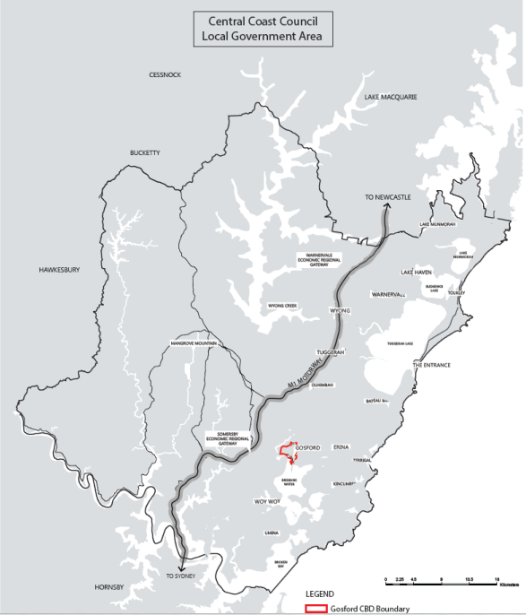

Figure 1 - Central Coast Local Government Area
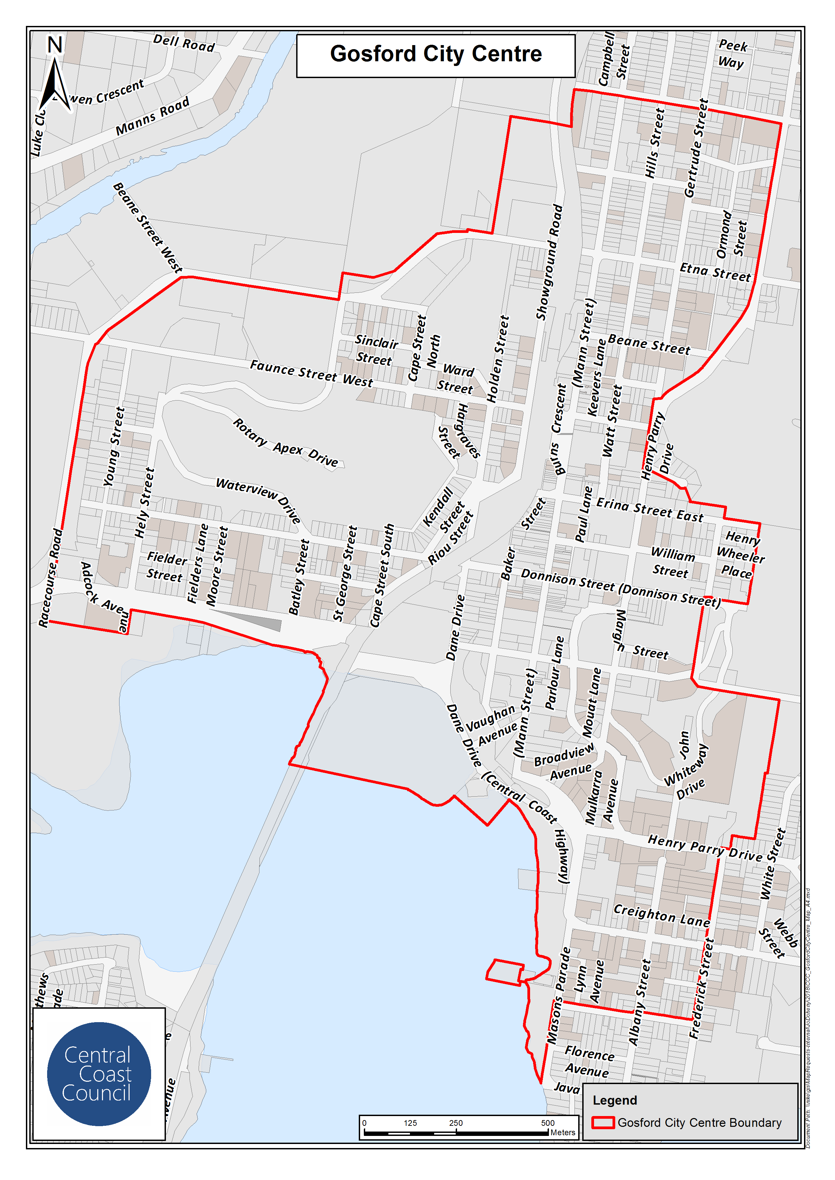
Figure 2 - Gosford City Centre

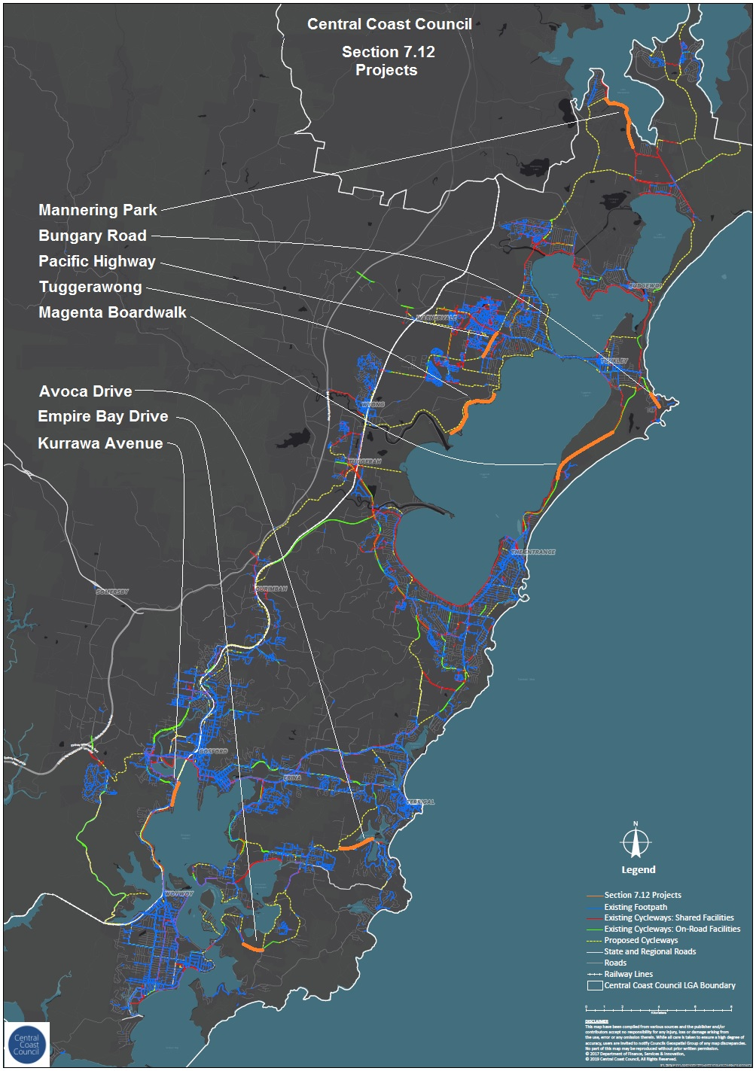

Figure 3 – Priority Projects Central Coast Bike Plan

Schedule 3 – Cost Summary Reports

A cost summary report is required to be submitted to allow council to determine the contribution that will be required. The following should be provided:

- A cost summary report must be completed for works with a value greater than $ 1,000,000
- A Quantity Surveyor’s Detailed Cost Report must be completed by a registered Quantity Surveyor for works with a value greater than $5,000,000

To avoid doubt, Section 208 of the Environmental Planning and Assessment Regulation 2021 sets out the following:

- The proposed cost of carrying out development must be determined by the consent authority by adding up all the costs and expenses that have been or will be incurred by the applicant in carrying out the development.

- The costs of carrying out development include the costs of, and costs incidental to, the following —

(a) if the development involves the erection of a building or the carrying out of engineering or construction work—
(i) erecting the building or carrying out the work, and
(ii) demolition, excavation and site preparation, decontamination or remediation,
(b) if the development involves a change of use of land—doing anything necessary to enable the use of the land to be changed,
(c) if the development involves the subdivision of land—preparing, executing and registering—
(i) the plan of subdivision, and
(ii) the related covenants, easements or other rights.

- In determining the proposed cost, a consent authority may consider an estimate of the proposed cost that is prepared by a person, or a person of a class, approved by the consent authority to provide the estimate.

- The following costs and expenses must not be included in an estimate or determination of the proposed cost—

(a) the cost of the land on which the development will be carried out,
(b) the costs of repairs to a building or works on the land that will be kept in connection with the development,
(c) the costs associated with marketing or financing the development, including interest on loans,
(d) the costs associated with legal work carried out, or to be carried out, in connection with the development,
(e) project management costs associated with the development,
(f) the cost of building insurance for the development,
(g) the costs of fittings and furnishings, including refitting or refurbishing, associated with the development, except if the development involves an enlargement, expansion or intensification of a current use of land,
(h) the costs of commercial stock inventory,
(i) the taxes, levies or charges, excluding GST, paid or payable in connection with the development by or under a law,
(j) the costs of enabling access by people with disability to the development,
(k) the costs of energy and water efficiency measures associated with the development,
(l) the costs of development that is provided as affordable housing,
(m) the costs of development that is the adaptive reuse of a heritage item.

Cost Summary Report
Development Cost no greater than $ 1,000,000

DEVELOPMENT APPLICATION No. REFERENCE:

COMPLYING DEVELOPMENT CERTIFICATE APPLICATION No.

CONSTRUCTION CERTIFICATE No. DATE:

APPLICANT’S NAME: _________________________________________________________________________
APPLICANT’S ADDRESS: _________________________________________________________________________
DEVELOPMENT NAME: _________________________________________________________________________
DEVELOPMENT ADDRESS: _________________________________________________________________________

ANALYSIS OF DEVELOPMENT COSTS:

Demolition and alterations | $ | Hydraulic services | $
Structure | $ | Mechanical services | $
External walls, windows and doors | $ | Fire services | $
Internal walls, screens and doors | $ | Lift services | $
Wall finishes | $ | External works | $
Floor finishes | $ | External services | $
Ceiling finishes | $ | Other related work | $
Fittings and equipment | $ | Sub-total | $

Sub-total above carried forward | $
Preliminaries and margin | $
Sub-total | $
Consultant Fees | $
Other related development costs | $
Sub-total | $
Goods and Services Tax | $
TOTAL DEVELOPMENT COST | $

I certify that I have:
- inspected the plans the subject of the application for development consent or construction certificate.
- calculated the development costs in accordance with the definition of development costs in clause 208 of the Environmental Planning and Assessment Regulation 2021 at current prices.
- included GST in the calculation of development cost.

Signed: ____________________________________
Name: ____________________________________
Position and Qualifications: ____________________________________
Date: ____________________________________

(Acknowledgment to City of Sydney for use of the model cost reports)

Quantity Surveyors Report

Registered* Quantity Surveyor’s Detailed Cost Report
Development Cost in excess of $ 5,000,000
*A member of the Australian Institute of Quantity Surveyors

DEVELOPMENT APPLICATION No. REFERENCE:

COMPLYING DEVELOPMENT CERTIFICATE APPLICATION No.

CONSTRUCTION CERTIFICATE No. DATE:

APPLICANT’S NAME: ___________________________________________________________________
APPLICANT’S ADDRESS: ___________________________________________________________________
DEVELOPMENT NAME: ___________________________________________________________________
DEVELOPMENT ADDRESS: ___________________________________________________________________

DEVELOPMENT DETAILS:

Gross Floor Area – Commercial | m² | Gross Floor Area – Other | m²
Gross Floor Area – Residential | m² | Total Gross Floor Area | m²
Gross Floor Area – Retail | m² | Total Site Area | m²
Gross Floor Area – Car Parking | m² | Total Car Parking Spaces
Total Development Cost | $
Total Construction Cost | $
Total GST | $

ESTIMATE DETAILS:

Professional Fees | $ | Excavation | $
% of Development Cost | % | Cost per square metre of site area | $ /m²
% of Construction Cost | % | Car Park | $
Demolition and Site Preparation | $ | Cost per square metre of site area | $ /m²
Cost per square metre of site area | $ /m² | Cost per space | $ /space
Construction – Commercial | $ | Fit-out – Commercial | $
Cost per square metre of commercial area | $ /m² | Cost per m² of commercial area | $ /m²
Construction – Residential | $ | Fit-out – Residential | $
Cost per square metre of residential area | $ /m² | Cost per m² of residential area | $ /m²
Construction – Retail | $ | Fit-out – Retail | $
Cost per square metre of retail area | $ /m² | Cost per m² of retail area | $ /m²

I certify that I have:
- inspected the plans the subject of the application for development consent or construction certificate.
- prepared and attached an elemental estimate generally prepared in accordance with the Australian Cost Management Manuals from the Australian Institute of Quantity Surveyors.
- calculated the development costs in accordance with the definition of development costs in clause 208 of the Environmental Planning and Assessment Regulation 2021 at current prices.
- included GST in the calculation of development cost.
- measured gross floor areas in accordance with the Method of Measurement of Building Area in the AIQS Cost Management Manual Volume 1, Appendix A2.

Signed: ____________________________________
Name: ____________________________________
Position and Qualifications: ____________________________________
Date: ____________________________________

(Acknowledgment to City of Sydney for use of the model cost reports)

